+A
PROJECT REPORT ON
Airline Ticket Booking System
SUBMITTED IN
PARTIAL FULFILLMENT OF

DIPLOMA IN ADVANCED COMPUTING (PG-DAC)
BY

SHOBHIT KUMAR GUPTA

UNDER THE GUIDENCE OF

AKASH SHELKE
AT

SUNBEAM INSTITUTE OF INFORMATION TECHNOLOGY,
KARAD

SUNBEAM INSTITUTE OF INFORMATION TECHNOLOGY,
KARAD.
CERTIFICATE
This is to certify that the project
Airline Ticket Booking System
Has been submitted by
SHOBHIT KUMAR GUPTA

In partial fulfillment of the requirement for the Course of PG Diploma in Advanced Computing (PG-DAC AUG2015) as prescribed by The CDAC ACTS, PUNE.
Place: Karad | Date: 27-JAN-2020
AKASH SHELKE | DIPESH MALVIYA
Project Guide | Alumni Mentor
INDEX
 | INTRODUCTION | 1
 | 1.1 Introduction | 2
 | Product Overview and Summary
 | 2.1 Purpose
 | 2.2 Scope
 | 2.3 User Classes and Characteristics
 | 2.4 Design and Implementation Constraints
 | REQUIREMENTS
 | 3.1 Functional Requirements
 | 3.1.1 Use case for Administrator.
 | 3.1.2 Use case for Customer.
 | 3.2 Non - Functional Requirements
 | 3.2.1 Usability Requirement
 | 3.2.2 Performance Requirement
 | 3.2.3 Reliability Requirement
 | 3.2.4 Portability Requirement
 | 3.2.5 Security Techniques
 | PROJECT DESIGN
 | 4.1 Data Model
 | 4.1.1 Database Design
 | 4.2 Process Model
 | 4.2.1 Functional Decomposition Diagram
 | 4.2.2 Data Flow Diagram (DFD)
 | TEST REPORT
 | PROJECT RELATED STATISTICS
 | CONCLUSION

ACKNOWLEDGEMENT
A project usually falls short of its expectation unlessaided and guided by the right persons at the right time. We avail this opportunity to express our deep sense of gratitude towards Mr. Sarang Patil (Director, SIIT Karad), Mr. Prashant Lad (Course Coordinator,SIIT, Karad) and Mr. AKASH SHELKE(Our Project Guide and Senior Faculty Member,SIIT Karad).
We are deeply indebted and grateful to them for their guidance, encouragement and deep concern for our project. Without their critical evaluation and suggestions at every stage of the project, this project could never have reached its present form.
Last but not the least we thank the entire faculty, especially Mr. Aakash Shelke , and the staff members of Sunbeam Institute of Information Technology, Karad for their support.

TEAMSUNBEAM
DAC August 2019 Batch
SIIT Karad
ABSTRACT
The main aim of the project was to develop a website which would facilitate the reservation of online air tickets through an effective and yet simple GUI for a normal passenger intending to travel in airways.
Nowadays these websites are grabbing the market like anything. The project is basically targeted at those people who would like to travel through air and have an Internet access. This website is developed to reduce the human efforts and get rid from the time consuming processes for booking and managing airline ticket. It maintains day to day records and provides ease of information to the user, which makes the website to create a user friendly environment for users and the one managing it.
It is a computerized system used to store and retrieve information and conduct transactions related to air travel. The project is aimed at exposing the relevance and importance of Airline Reservation Systems. It is projected towards enhancing the relationship between customers and airline agencies, and thereby making it convenient for the customers to book the flights as when they require such that they can utilize this software to make reservations.

INTRODUCTION

The Project is about Airlines Ticket Booking System in which we will concentrated on ticket booking system based on the user input requirements. The purpose of this project is to allow customers to interact and provide them some basic information such as all flights information, availability of accommodation in flights and ticket booking as per class they want to choose.
This project is an implementation of a general Airline Ticketing website like GoIndigo, which helps the customers to search the availability and prices of various airline tickets, along with the different packages available with the reservations. This project also covers various features like online registration of the users, modifying the details of the website by the management staff or administrator of the website, by adding, deleting or modifying the customer details and flights details. In general, this website would be designed to perform like any other airline ticketing website available online.
It eventually evolved into the computer reservations system (CRS). A computer reservation system is used for the reservations of a particular airline and interfaces with a global distribution system (GDS) which supports travel agencies and other distribution channels in making reservations for most major airlines in a single system.
Today all persons are busy with their schedule and no one have time to make a trip for holidays with their family. And this Airline Reservation Process is very difficult to understand in General meaning. But we are providing a Solution for that Problem.
This system provides a facility to easy access towards a customers and a real time users. They can easily connected through it and just 3 steps. There is no requirement for any type of Agent. We are giving a all this facility in one project “Airline Ticket Booking System”.

SCOPE OF THE PROJECT

> This project designs and implements air ticket reservation system. Supported by a well-designed database, all available air flight information is integrated together and can be accessed easily through a single point. A friendly user interface is provided so that various combinations of search criteria can be fetched from user. The air ticket reservation system provided both customer and administration interfaces.

OBJECTIVE OF THE PROJECT-

~ General Objective-
> The main goal of the proposed system is to make online the processes of the air ticket reservation.

~ Specific Objectives-
> To ensure that ticket reservation is easy and user friendly for customers.
> To satisfy customers need by reaching them at their place.
> Reduce the work load of the ticket officers.

# PROJECT OVERVIEW-
>The Airline Reservation System project is an implementation of a general Airline Ticketing website, which helps the customers to search the availability and prices of various airline tickets with the reservations. This project also covers various features like online registration of the users, modifying the details of the website by the administrator of the website, by adding, deleting or modifying the customer details and flights.
In general, this website would be designed to perform like any other Airline ticketing website available online.

REQUIREMENTS

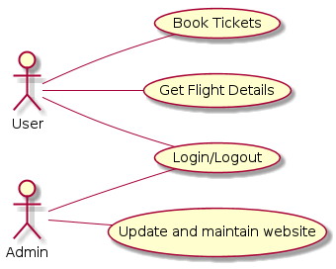

Description:
In this project we concentrated on ticket booking system based on the user input requirements. The purpose of this project is to allow customers to interact and provide them some basic information such as all flights information,availability of accommodation in flights and ticket booking as per class they want to choose.

FUNCTIONAL REQUIREMENTS

User->
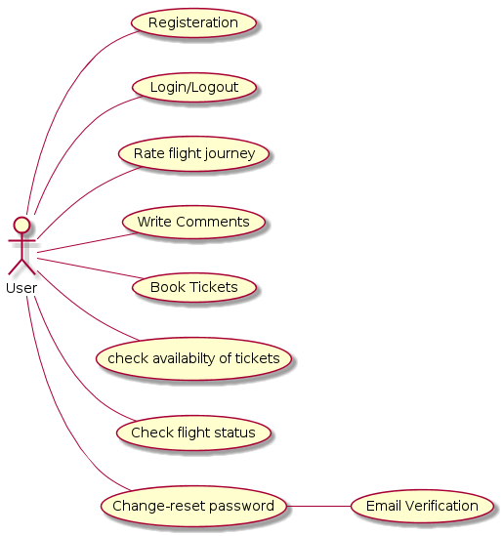

User Functionalities

User Registration:-
In this user register with the application by providing all the necessary details, in order to make reservations or bookings for flights.
+Will provide the necessary registration details ~ Name, Address, Mobile No., E-mail, Username, Create-password...

-> User Login/Logout:-
In this scenario user logs into the application, with the username and password he has provided while registering with the system and logout whenever they want .

-> Book Tickets:-
In this scenario user books airline tickets.
1) user would be able to search flights on the basis of source and destination.
2) user would be able to search flights on the basis of schedule of flights.
3) user would be able to book tickets based on the class they want to travel in(Executive or Business).

-> Rate Flight Journey:-
In this scenario user provides the rating to services received by the user or experienced while booking and traveling.

-> Write Comments:-
In this scenario user writes the comment on the basis of services or experiences faced by him while booking and traveling(Good or Bad).

-> Check Availability of Tickets:-
In this scenario user can check the available tickets in the respective flights and can plan their booking accordingly.

-> Check Flight Status:-
In this scenario user would be able to search flights on the basis of schedule of flights and plan their booking accordingly.

-> Change-Reset Password:-
In this scenario user can change or reset password in case of user might have forgot his/her password and this process of password change is carried by entering the OTP received in Email for verification purpose.

+Email Verification:
OTP is send for verification purpose to the respective email provided by the user and that OTP is used while reset of a password .

ADMIN ->
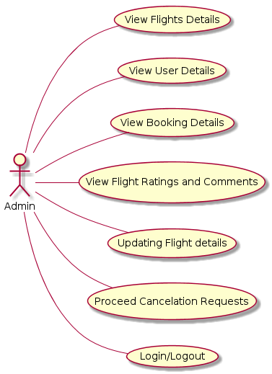

ADMIN FUNCTIONALITIES

-> Login/Logout:-
In this the administrator of the application, logs into the system and logs out after the work is done.

-> Update Flight Details:-
In this scenario where the administrator adds, deletes or modifies flight information in the system database.

-> View Flight Details:-
In this scenario, the administrator can view the details of the flight information in the application database.

-> View User Details:-
In this scenario, the administrator can view the details of all the user information, who have registered in the website by fetching all the details from the database maintained for the site.

-> View Booking Details:-
In this scenario, the administrator can view the details of all the booked tickets till time by fetching all the necessary information stored in the database .

-> View Ratings and Comments:-
In this scenario, the administrator can view the ratings and experiences shared by user in the form of comments for each experience they have faced during booking and flight.

-> Proceed Cancellation Request:-
In this the administrator of the application, will approve the cancellation request arise by any user in case of cancellation of a ticket user have booked from the website.

3.2 Non - Functional Requirements
Non-functional requirements are not non-functional at all. Rather, they describe various quality factors, or attributes, which affect the functionality effectiveness. They do not exist in the abstract but only with respect to relevant functionality such as, usability, reliability, and maintainability.
For instance, if the software doesn't satisfy relevant usability requirements for applicable functional usage, users can't use it appropriately and thus will not achieve the required functioning. Inadequate usability may cause errors which nullify the value of the functioning, such as miscalculating something. Usability difficulties could cause the user not to use (all) the functions necessary to achieve the value, perhaps because they're not able to employ the necessary functions. It may take so long and be so unpleasant to use the software that the user can't use it as much as is needed or even abandons its use entirely.

3.2.1 Usability Requirement:
Usability is the ease of use and learnnability of a human-made object. The object of use can be a software-application, website, book, tool, MACHINE, process, or anything a human interacts with. A usability study may be conducted as a primary job function by a usability analyst or as a secondary job function by designers, technical writers, marketing personnel, and others. It is widely used in consumer electronics, communication, and knowledge transfer objects and mechanical objects such as a door handle or a hammer. Usability includes methods of measuring usability, such as needs analyst and the study of the principles behind an object's perceived efficiency or elegance. In human-computer interaction and computer science, usability studies the elegance and clarity with which the interaction with a computer program or a web site is designed. Usability differs from user satisfaction and user experience because usability also considers usefulness.

Usability Requirements for this project design should support the following from the perspective of its primary users:
- Efficiency of use: goals are easy to accomplish quickly and with few or no user errors.
- Intuitiveness: the interface is easy to learn and navigate; buttons, headings, and help/error messages are simple to understand.
- Low perceived workload: the interface appears easy to use, rather than intimidating, demanding and frustrating.

3.2.2 Performance Requirement:
Performance requirement within system engineering, encompasses the set of roles, skills, activities, practices, tools, and deliverables applied at every phase of the systems development life cycle which ensures that a solution will be designed, implemented, and operationally supported to meet the non- functional requirements for performance.
In our project basic performance requirements get maintain by using object oriented concepts such as major pillars of object oriented programming thought process are ‘Abstraction’, ‘Modularity’ ,‘Encapsulation’, ‘Hierarchy’ and minor pillars are ‘Concurrency’, ‘Persistence’, ‘Typing’. These pillars keep the inter-functionalities for the project as ‘loosely coupled and highly cohesive’

3.2.3 Reliability Requirement:
Reliability Requirement is requirement that emphasizes dependency in the lifecycle management of a product. Dependability, or reliability, describes the ability of a system or component to function under stated conditions for a specified period of time. Reliability requirement may also describe the ability to function at a specified moment or interval of time (Availability). Reliability is theoretically defined as the probability of success (Reliability=1-Probability of Failure), as the frequency of failures; or in terms of availability, as a probability derived from reliability, testability and maintainability. Testability, Maintainability and maintenance are often defined as a part of "reliability engineering" in Reliability Programs. Reliability plays a key role in the cost-effectiveness of systems.
In this project, to achieve the reliability requirement of the software the various programming layers have to reliable on each other inclusively. In this project, to achieve the reliability requirement of the software the various programming layers have to reliable on each other inclusively.
For example in our project, we have database, POJO layer, DAO layer, Controller layer, View layer. Among these, each layer has to relay on other layer. For example, POJO layer has dependency on database, for the implementation of DAO layer it has to take some help of POJO layer and so on. This activity shows the reliability requirements of our project.
4 PROJECT DESIGN

Architectural Model Used => Spring MVC Framework

Spring MVC helps in building flexible and loosely coupled web applications. The Model-view-controller design pattern helps in seperating the business logic, presentation logic, and navigation logic.
Models are responsible for encapsulating the application data.
The Views render a response to the user with the help of the model object.
Controllers are responsible for receiving the request from the user and calling the back-end services.

Benefits of the Spring Web MVC Framework
The Spring Web MVC Framework is a robust, flexible, and well-designed framework for rapidly developing web applications using the MVC design pattern
n Easier testing—This is a common theme you will find across all the Spring classes. The fact that most of Spring’s classes are designed as JavaBeans enables you to inject test data using the setter methods of these classes. Spring also provides mock classes to simulate Java HTTP objects (HttpServletRequest, for example), which makes unit testing of the web layer much simpler.
n Bind directly to business objects—Spring MVC does not require your business (model) classes to extend any special classes; this enables you to reuse your business objects by binding them directly to the HTML forms fields. In fact, your Spring Web MVC Concepts 129 controller classes are the only ones that are required to extend Spring classes (or implement a Spring controller interface).
n Clear separation of roles—Spring MVC nicely separates the roles played by the various components that make up this web framework. For example, when we discuss concepts such as controllers, command objects, and validators, you will begin to see how each component plays a distinct role.
n Adaptable controllers—If your application does not require an HTML form, you can write a simpler version of a Spring controller that does need all the extra components required for form controllers. In fact, Spring provides several types of controllers, each serving a different purpose. For example, there are no-form controllers, simple form controllers, wizardlike form controllers, views with no controllers, and even prepackaged controllers that enable you to write views without your own custom controller.
n Simple but powerful tag library—Spring’s tag library is small, straightforward, but powerful. For example, Spring uses the JSP expression language (EL) for arguments to the
n Web Flow—This module is a subproject and is not bundled with the Spring core distribution. It is built on top of Spring MVC and adds the capability to easily write wizardlike web applications that span across several HTTP requests (an online shopping cart, for example).
n View technologies and web frameworks—Although we are using JSP as our view technology, Spring supports other view technologies as well, such as Apache Velocity (jakarta.apache.org/velocity/) and FreeMarker (freemarker.org).This is a powerful concept because switching from JSP to Velocity is a matter of configuration. Furthermore, Spring provides integration support for Apache Struts (struts. apache.org),Apache Tapestry (jakarta.apache.org/tapestry), and OpenSymphony’s WebWork (opensymphony.com/webwork/). n Lighter-weight environment—As I mentioned in the previous chapter, Spring enables you to build enterprise-ready applications using POJOs; the environment setup can be simpler and less expensive because you could develop and deploy your application using a lighter-weight servlet container.

Flowdiagram of Spring MVC

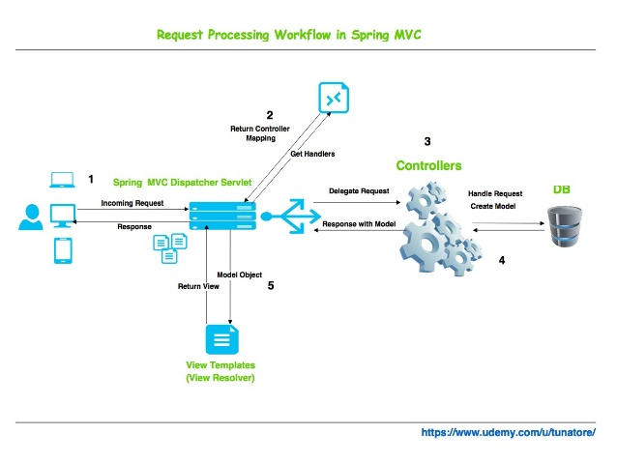

WEB SERVER :

- Tomcat Server

  - Tomcat is enterprise class, robust web server which comes bundled with JavaServlets and JSP that provides a java application server environment

  - One of the other major issues why we chose Tomcat was Scalability. Presently Java is our core technology used for portability and in future if we want to make our site be reachable to users using Microsoft products we would be having no conflicts between the servers because Tomcat can be deployed as either a standalone product with its own internal Web server or in conjunction with several other Web servers, including

Netscape Enterprise Server.
Microsoft Internet Information Server.
Microsoft Personal Web Server.

  - It adheres to the latest standards, which expands the security features.
Configuration, tuning and maintenance are lot easier than compared to other prevailing web servers.

  - Since we were not going for enterprise java beans in our project we didn’t feel the necessity of going for other application servers like J2EE or JBOSS .We were basically looking for a reliable web server which would be compatible with both the front-end and back-end technologies we were using and our ultimate choice was Apache’s Tomcat Web Server.

4.1 Data Model
A data model organizes data elements and standardizes how the data elements relate to one another. Since data elements document real life people, places and things and the events between them, the data model represents reality. A data model is a set of symbols and text used for communicating a precise representation of an information system. A data model provides the details of information to be stored, and is of primary use when the final product is the generation of computer software code for an application or the preparation of a functional specification to aid a computer software make-or-buy decision. The figure is an example of the interaction between process and data models.
Data models are often used as an aid to communication between the business people defining the requirements for a computer system and the technical people defining the design in response to those requirements. They are used to show the data needed and created by business processes.
The data model simply describes the structure of data entities and their relationships. For example, in a banking system, entities will typically include Account, Customer and Loan. Account has several attributes, such as account number, type (savings or checking), status, and current balance. A relationship may dictate that one customer can have one or more accounts, and one account is associated to one or two customers. Data modelling spans the evolution of the high-level model that displays the data entities in a given business domain into a model that shows details of how the data is stored. There are different stages of data models:
- ➢ Conceptual data model.
- ➢ Logical data model.
- ➢ Physical data model.

4.1 Database Design
Database design is the process of producing a detailed data model of a database. This data model contains all the needed logical and physical design choices and physical storage parameters needed to generate a designin a data definition language, which can then be used to create a database. A fully attributed data model contains detailed attributes for each entity. The term database design can be used to describe many different parts of the design of an overall database system. Principally, and most correctly, it can be thought of as the logical design of the base data structures used to store the data. In the relational model these are the tables and views. In an object database the entities and relationships map directly to object classes and named relationships. However, the term database design could also be used to apply to the overall process of designing, not just the base data structures, but also the forms and queries used as part of the overall database application within the database management system (DBMS).
The process of doing database design generally consists of a number of steps which will be carried out by the database designer. Usually, the designer must
- Determine the data to be stored in the database.
- Determine the relationships between the different data elements.
Superimpose a logical structure upon the data on the basis of these relationships.

Within the relational model the final step above can generally be broken down into two further steps that of determining the grouping of information within the system, generally determining what are the basic objects about which information is being stored, and then determining the relationships between these groups of information, or objects. This step is not necessary with an object database.

Database Table Design :-
User table:
Field | Type | Null | Key | Default | Extra
u_id | int(11) | NO | PRI |  | auto_increment
u_title | varchar(5) | NO
u_firstname | varchar(30) | NO
u_lastname | varchar(30) | NO
u_dob | date | NO
u_email | varchar(40) | NO | UNI
u_mob | varchar(10) | NO
u_password | varchar(20) | NO

Admin table:
Field | Type | Null | Key | Default | Extra
a_id | int(11) | NO | PRI |  | auto_increment
a_title | varchar(5) | NO
a_firstname | varchar(30) | NO
a_lastname | varchar(30) | NO
a_dob | date | NO
a_email | varchar(40) | NO | UNI
a_mob | varchar(10) | NO
a_password | varchar(20) | NO

Flight_datails:
Field | Type | Null | Key | Default | Extra
f_id | varchar(10) | NO | PRI
f_source | varchar(30) | NO
f_destination | varchar(30) | NO
f_capacity | int(11) | NO
departure_time | date | YES
arrival_time | date | YES

Class table:
Field | Type | Null | Key | Default | Extra
c_id | varchar(2) | NO | PRI
c_type | varchar(20) | NO

flight_class table:
Field | Type | Null | Key | Default | Extra
fc_id | varchar(5) | NO | PRI
f_ic | varchar(10) | YES | MUL
c_id | varchar(2) | YES | MUL
fc_capacity | int(11) | NO
fc_price | int(11) | NO

passenger_details table:
Field | Type | Null | Key | Default | Extra
p_id | int(11) | NO | PRI |  | auto_increment
u_id | int(11) | YES | MUL
p_name | varchar(50) | NO
p_sex | varchar(10) | NO
p_age | int(11) | NO

Booking table:
Field | Type | Null | Key | Default | Extra
b_id | int(11) | NO | PRI |  | auto_increment
u_id | int(11) | YES | MUL
fc_id | varchar(5) | YES | MUL
no_of_seats | int(11) | YES
b_date | date | YES

Transaction table:
Field | Type | Null | Key | Default | Extra
t_id | int(11) | NO | PRI |  | auto_increment
b_id | int(11) | YES | MUL
t_date_time | date | NO
amount | int(11) | NO
status | tinyiny(1) | YES

rating table:
Field | Type | Null | Key | Default | Extra
r_id | int(11) | NO | PRI |  | auto_increment
u_id | int(11) | YES | MUL
f_id | varchar(10) | YES | MUL
Rating | float | NO
Comment | varchar(250) | YES

5. TEST REPORT
System testing is designed to uncover the weaknesses that were not found in earlier test. In the testing phase, the program is executed with the explicit intention of finding errors. This includes forced system failures and validation of the system, as its user in the operational environment will implement it. For this purpose test cases are developed. When a new system replaces the old one, such as in the present case, the organization can extract data from the old system to test them on the new. Such data usually exist in sufficient volume to provide sample listings and they can create a realistic environment that ensures eventual system success. Regardless of the source of test data, the programmers and analyst will eventually conduct four different types of tests

System Testing
The system testing deals with the process of testing the system as a whole. This is done after the integration process. Moving through each module from top to bottom tests the entire . The verifcation and validation process are then The errors that occur the testing phase are eliminated and a well functioning system is developed. Test case design focuses on a set of techniques, which meets all testing objectives, which are mentioned below.
1. Testing is a process of executing a program with the intent of finding an error.
2. A successful test is one that uncovers an as yet undiscovered error.Testing demonstrates that software functions work according to specifcations. In addition data collected from testing provides a good indication of software reliability and some indication of software quality as a whole.Testing results in the deduction in the numbers of errors. Critical modules are tested as early as possible .The following tests have been carried out after developing the system.

Various Testing Methods:
Unit testing focuses verifcation efforts on the smallest unit of the software design, the module. This is also known as Module Testing. The modules are tested separately. This testing is carried out during programming stage itself.

Validation Testing:
Validation testing can be defined in many ways but a simple defnition is that validation succeeds when the software functions in a manner that can be reasonably expected by the users .After validation test has been conducted one of the two possible conditions exists
1. The function or the performance characteristics to confirm specifcation and are accepted.
2. A deviation from specification is uncovered and a deficiency listis created.

Output Testing:
After performing the validation testing the next step is output testing of the proposed system since no system is useful if it does not produce the required output in the specific format.
The outputs generated or displayed by the system under consideration are tested by asking the users about the formats required by them.
1. PROJECT RELATED STATISTICS:
Project related statistics shows what the realistic scenario of our project is. It includes actual look and feel, functionality of the project.
Following are the some screenshots of our project that is Project management System.

System Maintenance & Evaluation
The maintenance activity consist of following tasks:
1. Backup
2. Diagnostic
3. Integrity changes
4. Recovery
5. Design changes
6. Performance tuning
These features ensure the availability of the databases
round the clock as the database maintenance is possible
online when the system is in use. RDBMS allows an online
maintenance, rapid recovery and software based fault
tolerance. The rapid recovery features allows the system
administrator to provide ‘time’ to go back for the recovery
of the data if the system fails due to power or network
crash. Based on this time, system automatically goes back
and collects all the changes and writes to disk.

7. CONCLUSION

The “Airline Ticket Booking System” is successfully designed and developed to fulfilling the necessary requirements, as identified in the requirements analysis phase, such as the system is very much user friendly, form level validation and field level validation are performing very efficiently.
The new computerized system was found to be much faster and reliable and user friendly then the existing system, the system has been designed and developed step by step and tested successfully. It eliminates the human error that are likely to creep in the kind of working in which a bulk quantity of data and calculations as to be processed. The system results in quick retrieval of information that is very vital for the progress any organization. Cost is minimized in case of stationary.
Burden of manual work is reduced as whenever transaction takes place, there is a no need to record it in many places manually.
Future Scope
The software has been developed in such a way that it can accept modifications and further changes. The software is very user friendly and future any changes can be done easily.
Software restructuring is carried out. Software restructuring modifies source code in an effort to make it amenable to future changes.
In general, restructuring does not modify the overall program architecture. It tends to focus on the design details of individual modules and on local data structure defined within modules.
Every system should allow scope for further development or enhancement. The system can be adapted for any further development. The system is so feasible to allow any modification need for the further functioning of programs.
Since the objectives may be brought broad in future, the system can be easily modified accordingly, as the system has been modularize. The future expansion can be done in a concise manner in order to improve the efficiently of the system.
BIBLIOGRAPHY
List of References: -
[1] “Computerized Reservation System”. Retrieved on May 14, 2012
fromhttp://en.wikipedia.org/wiki/Computer_reservations_system.htm.

[2]Wikipedia(2012),http://en.wikipedia.org/wiki/Computer_reservations_systemaccessedon May 26, 2012.

Web Reference
➢ www.wikipedia.org
➢ www.codeguru.com/vb
➢ www.oop.com

LIST OF TABLES
Section | Table Title | Page

LIST OF FIGURES
Section | Figure Title | Page

